Build the Customized Embedded Linux for Beagle bone black from scratch

Requirements for building the embedded Linux

1. Cross-Compiler Toolchain
2. Bootloader
3. Linux kernel
4.Device Tree files
5.Root File system

Building the own Cross-Compiler Tool-chain

1.Set Up Your Build Environment
$ sudo apt-get update
$ sudo apt-get install build-essential libncurses5-dev bison flex libssl-dev

2. Download the Buildroot and extract it
$ wget https://buildroot.org/downloads/buildroot-2024.02.4.tar.gz
$ tar -xzf buildroot-2024.02.4.tar.gz

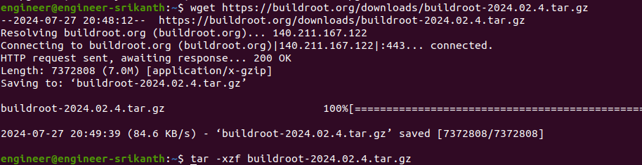
3.Configure the Beaglebone black
$ make menuconfig

Configure the below parameters in the menuconfig
Select the target Architecture (Arm) and its varient (cortex-A8)
Select application binary interface (EABIHF) which is hard-float-ABI.
Choose the buildroot or external toolchain
Choose the C library (glibc or uglibc)
Set the Toolchain options (arm-linux-gnueabihf).
Choose specified kernel headers.

4. Build the Toolchain
$ make toolchain

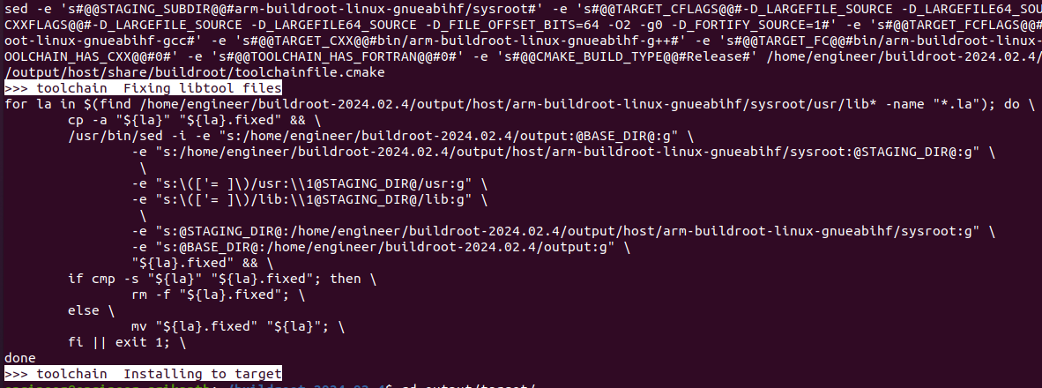

Toolchain file is located at below folder
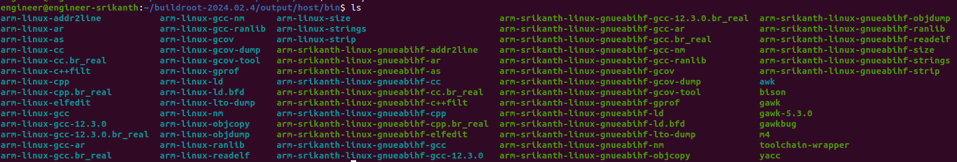
Building the Bootloaders for BBB(MLO,u-boot.img)

Steps to Build the U-Boot with Your Custom Toolchain

1. Export the toolchain path
$ export CROSS_COMPILE =/home/engineer/buildroot-2024.02.4/output/host/bin/arm-srikanth-linux-gnueabihf-

2.Clone the U-boot source code
$ git clone https://github.com/u-boot/u-boot.git

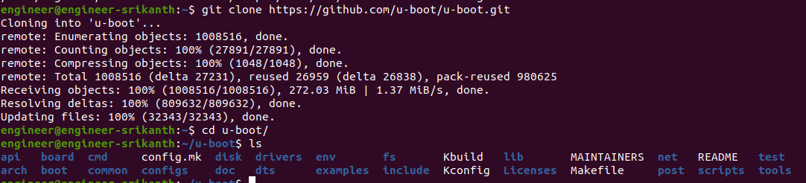

3.Configure U-Boot for Beaglebone Black:
$ make am335x_evm_defconfig

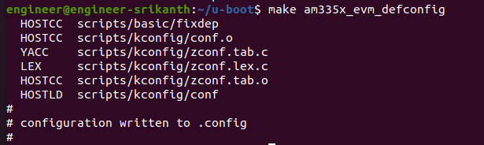
4.Build U-boot
$ make all

Building the Linux kernel

1.Download the Linux Kernel Source Code from kernel.org
or
$ git clone https://github.com/beagleboard/linux.git (for latest version)

2.Generate the default configuration for Beaglebone black
$ make ARCH=arm CROSS_COMPILE=/home/engineer/buildroot-2024.02.4/output/host/bin/arm-srikanth-linux-gnueabihf- defconfig

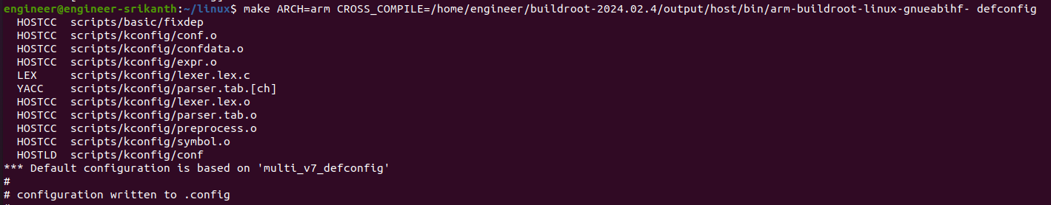

3.Enabling Hotplug Support in the Kernel Configuration
$ make ARCH=arm CROSS_COMPILE=/home/engineer/buildroot-2024.02.4/output/host/bin/arm-srikanth-linux-gnueabihf- menuconfig

Navigate Through the Menu.
- Go to Device Drivers.
- Scroll down and select Generic Driver Options.
- Within Generic Driver Options, find and select Support for uevent helper
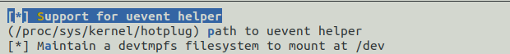

4.Build the kernel
$ make ARCH=arm CROSS_COMPILE=/home/engineer/buildroot-2024.02.4/output/host/bin/arm-srikanth-linux-gnueabihf- zImage modules dtbs
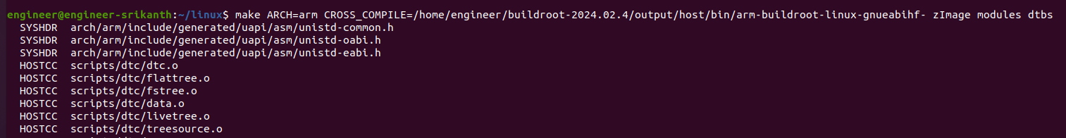

Creating the Root Filesystem using busybox

1.Clone the BusyBox repository and configure it.
$ git clone git://busybox.net/busybox.git

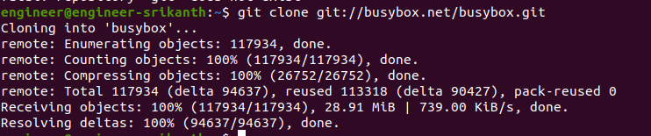
$ cd busybox
$ make defconfig

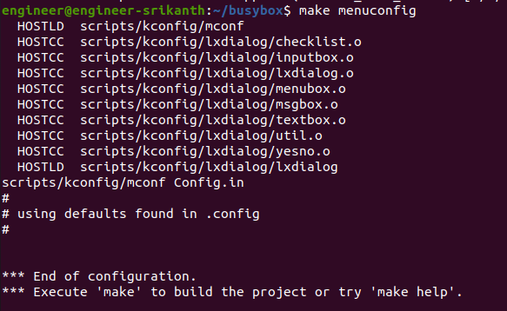

$ make
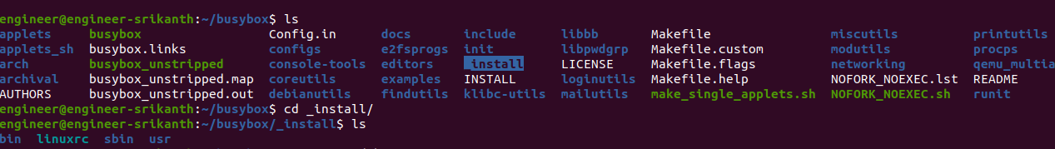
$ make install

2.Create the Root Filesystem Structure
$ cd _install
$ mkdir -p dev etc etc/init.d proc sys tmp var var/log mnt

Here is a reasonable minimum set of directories for your root Filesystem.
- /dev -- Device files, required to perform I/O
- /proc -- Directory stub required by the proc filesystem
- /etc -- System configuration files
- /sbin -- Critical system binaries
- /bin -- Essential binaries considered part of the system
- /lib -- Shared libraries to provide run-time support
- /mnt -- A mount point for maintenance on other disks
- /usr -- Additional utilities and applications
3. Installing Kernel Modules into the Root Filesystem.
$ sudo make -j12 ARCH=arm INSTALL_MOD_PATH=/home/engineer/busybox-1.34.1/_install/ modules_install
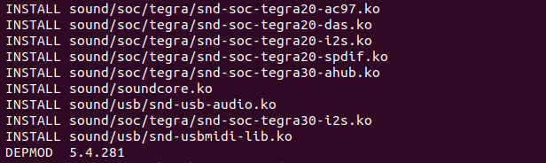
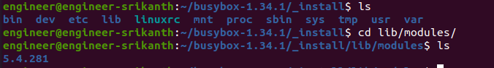
4.Copying Shared Library Files into the Root Filesystem
Navigate to sysroot

$ sudo cp -r lib/* /home/engineer/busybox-1.34.1/_install/lib

5.create the device nodes
$ sudo mknod -m 600 dev/console c 5 1
$ sudo mknod -m 666 dev/null c 1 3
$ sudo mknod -m 666 dev/tty c 5 0

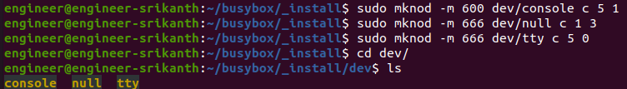
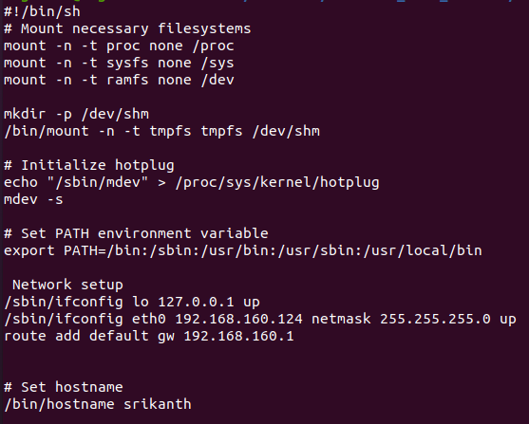
6.Create the rcS Script for init process

mount -n -t proc null /proc
mount -n -t sysfs null /sys
mount -n -t ramfs null /dev
These commands are mounting special system filesystems.

echo "/sbin/mdev" > /proc/sys/kernel/hotplug
mdev -s

- mdev is a lightweight device manager for embedded systems, often used in place of udev.
- The first line tells the kernel to use /sbin/mdev as the handler for hotplug events (e.g., when devices are plugged in or removed).
- mdev -s scans the existing devices and populates the /dev directory with corresponding device nodes.
export PATH=/bin:/sbin:/usr/bin:/usr/sbin:/usr/local/bin

- Sets the PATH environment variable, which tells the shell where to look for executable files.
/sbin/ifconfig lo 127.0.0.1 up
- /sbin/ifconfig eth0 192.168.160.124 netmask 255.255.255.0 up
- route add default gw 192.168.160.1

- These commands configure the network interfaces(static IP address).
- lo: Configures the loopback interface with the IP address 127.0.0.1. This is essential for local communication between services on the same device.
- eth0: Configures the Ethernet interface eth0 with the static IP address 192.168.160.124. The netmask address is 255.255.255.0 and gateway address is 192.168.160.1.

mkdir -p /dev/shm /bin/mount -n -t tmpfs tmpfs /dev/shm

Creates a shared memory directory (/dev/shm) and mounts a temporary filesystem (tmpfs) to it. This is often used for inter-process communication (IPC) that requires shared memory.

6.Give executable permission to rcS file.
$ chmod +x rcS

7.Configure the Inittab in etc folder
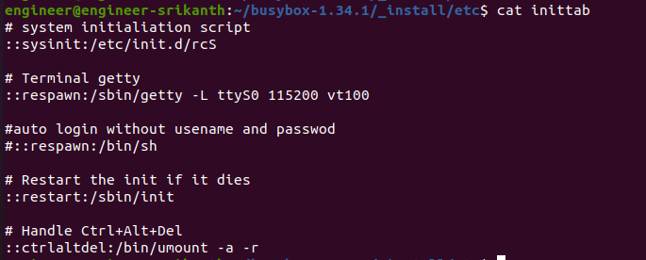

8.Create the username
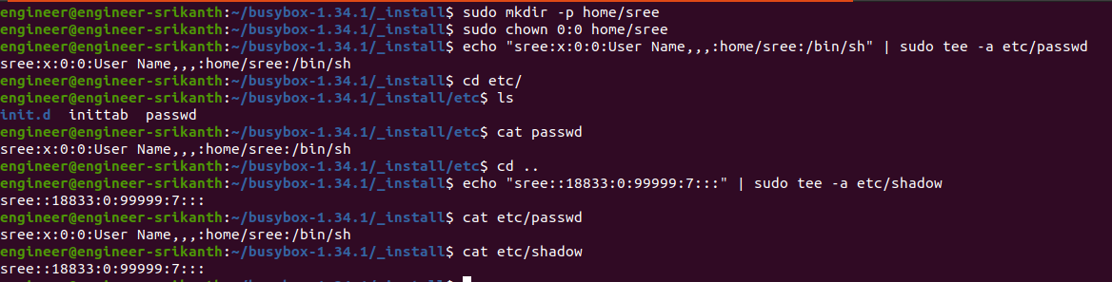
echo "sree:x:0:0:User Name,,,:home/sree:/bin/sh" | sudo tee -a etc/passwd
echo "sree::18833:0:99999:7:::" | sudo tee -a etc/shadow
After booting the BBB add password to username
# passwd sree

Create a tarball of the root filesystem.
$ cd ..
$ tar -cvf rootfs.tar -C _install .
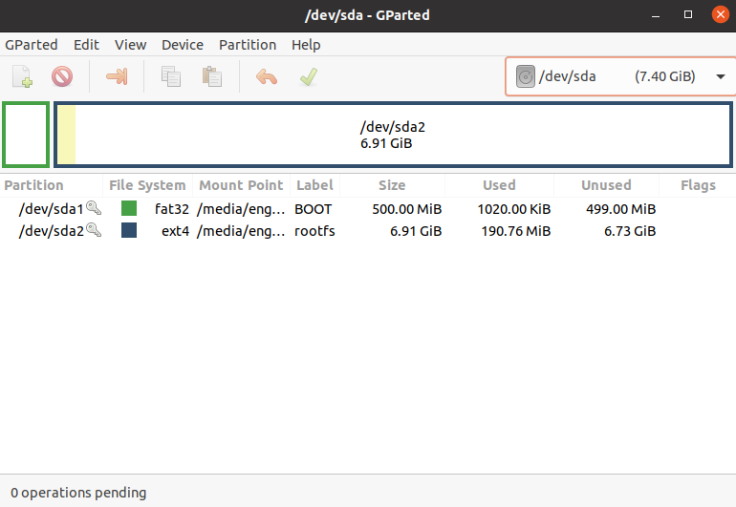
Write uEnv.txt for auto booting.
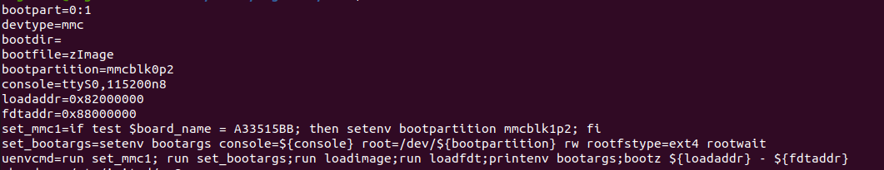
Inserted the SD card and create the partitions using gparted application

Copy the MLO, u-boot.img, zImage, am335x-boneblack.dtb and uEnv.txt files into SD card boot partition
sudo cp MLO u-boot.img /media/engineer/BOOT/
sudo cp zImage /media/engineer/BOOT/
sudo cp am335x-boneblack.dtb /media/engineer/BOOT/
sudo cp uEnv.txt /media/engineer/BOOT/

Copy the rootfs tarball into the SD card
sudo tar -xvf rootfs.tar -C /media/engineer/rootfs/

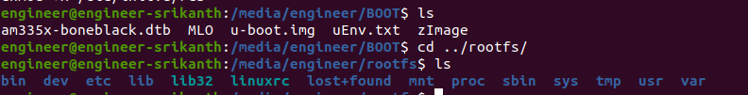

Eject the SD card from the host and insert into the Beagle bone black
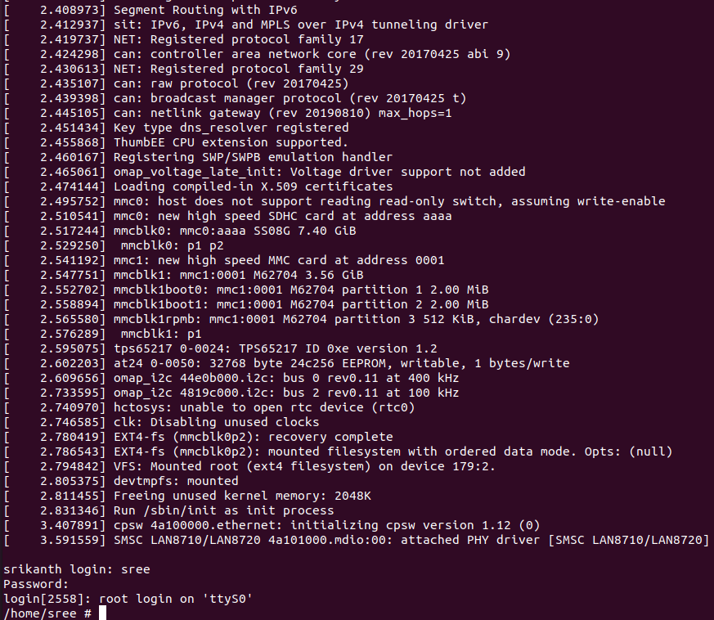

Manual booting steps
fatload mmc 0:1 0x82000000 zImage
fatload mmc 0:1 0x88000000 am335x-boneblack.dtb
setenv bootargs console=ttyO0,115200n8 root=/dev/mmcblk0p2 rw rootfstype=ext4 rootwait init=/sbin/ini
bootz 0x82000000 - 0x88000000

